***Mini bowling game***

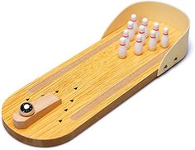

*The mini Bowling game is made of wood and metal marbles. The gameplay is relatively simple. Suitable as gifts for children, gifts for friends.*